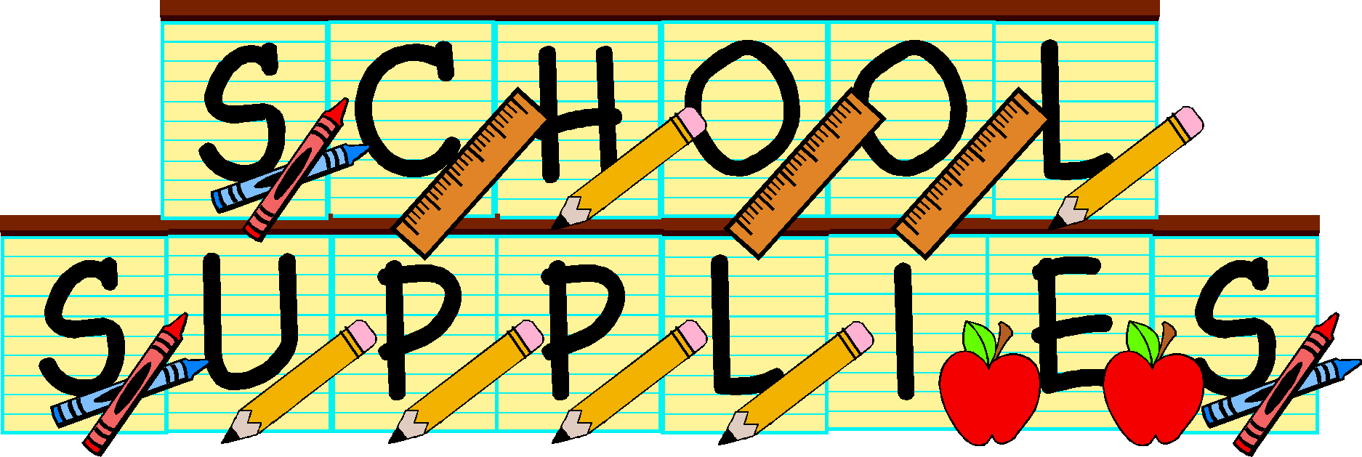

School 14 Siragusa   
Supply List – Mrs. Meegan (MA-23)

**Please note that pencils, hygiene products and tissues will be collected and stored in the classroom. The class will share these supplies to create a sense of community.**

**Please send in a change of clothes to be kept in the classroom in case of an emergency.**

* 5 Composition Notebooks
* 6 two-pocket folders
* 1 binder (at least 1 inch)
* 4 packages of index cards
* 2 boxes of pencils
* 2 highlighters
* 1 pack of dry erase markers
* 1 box of colored pencils/markers/crayons (whichever you would prefer)
* 1 package of white paper/construction paper (whichever you would prefer)
* 1 box of **gallon** sized storage bags
* 1 box of **sandwich** sized storage bags
* 3 boxes of tissues
* 2 containers of Clorox wipes
* 1 bottle of hand sanitizer
* 1 roll of paper towel
* 1 Pair of headphones
* 1 Labeled reusable water bottle